# Connected Humber V3 PCB Layout

## PCB Layout

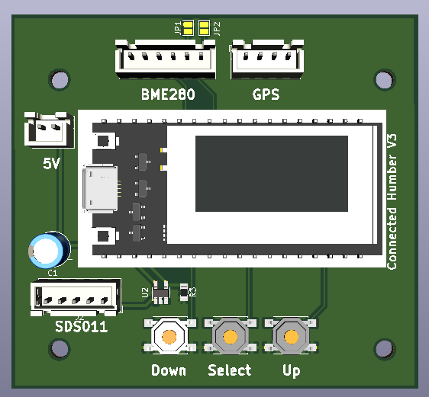

C1 is an electrolytic capacitor rated 470uF 10v which props up the 5V to the Heltec V2 when the SDS011 switches on.

The Heltec MUST be a V2, which has two Vext pins that are used to power the BME280 and switch power on/off to the SDS011. U2 and R3 form the highside switch which turns the 5V on/off to the SDS011.

### Solder jumpers

The 6 pin BME280 and BME680 have different default I2C addresses (0x77) compared to the 4 pin BME280 which has a default address of 0x76. The first 4 pins of each device have the same designations (VCC,GND,SCL,SDA) in the same order. Pins 5 and 6 have different uses.

The CH firmware checks the available addresses automatically so you don’t really need to use these jumpers. However, if you want to force the address to use with alternative firmware then:-

JP1 selects a 6 pin BME280 IC2 address of 0x76

JP2 selects a 6 pin BME680 IC2 address of 0x76

Only one jumper should be used at any one time.